Design Thinking: A UX design framework

In the world of UX design, a **framework** is a conceptual tool that provides guidance on the best practices and processes for solving  problems and building solutions that solve the problems of real users. Frameworks provide structure for the design process and foster collaboration, which can spark innovations. Most UX designers follow a specific framework or process when approaching their work, from the first idea all the way through to the final launch of a product.

In this certificate program, you’ll follow the **Design Thinking** framework to sequence the assignments that contribute to the designs that you’ll create throughout the program. The Design Thinking framework is a user-centered approach to problem-solving that includes activities like research, prototyping, and testing to help you understand who your user is, what their problems are, and what your design should include.

The Design Thinking framework involves the following phases: empathize, define, ideate, prototype, and test.

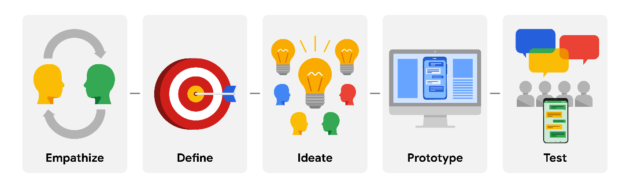

Though it may sound like a linear process, the Design Thinking framework should be iterative, which means that you’ll repeat certain phases as you refine your designs. For example, depending on the feedback you receive during testing, you might need to conduct additional research, brainstorm new ideas, or develop new prototypes.

Let’s look at the five phases of the Design Thinking framework to learn more about which activities you’ll perform during each one. Keep in mind that the Design Thinking framework as presented here is an idealized model for UX designers to follow, so you might see some variation in its implementation  between different companies, teams, or projects.

**Empathize**

During the **empathize** phase, your primary goal is to learn more about the user and their problems, wants, and needs, and the environment or context in which they’ll experience your design. The most important part of the empathize phase is to step away from your assumptions and guesses and let your research findings inform your decision-making in later design phases.

Your user research might include user surveys, interviews, and observation sessions, and you might also need to conduct some research on the competitors’ products to determine how your user frames competitors’ products as part of their daily life and daily problem-solving.

**Define**

In the **define** phase, you’ll analyze your research findings from the empathize phase and determine which user problems are the most important ones to solve, and why. This will drive you toward a clear goal for the design of the product.

The most important outcome of this phase is a clear problem statement, which is a description of the user’s need that your designs will address. You might also develop a value proposition, which is a summary of why your user would or should use the product or service that you’re designing.

**Ideate**

After you land on a user problem and establish why it’s an important one to solve, it’s time for the **ideate** phase. The goal of ideation is to come up with as many design solutions as possible—don’t settle for your first solution because the most obvious solution is not always the right one.

Ideation involves collaborative brainstorming with other members of your team to generate as many solutions as possible to a problem. This could include marketing, engineering, product management, or any other stakeholders for the product or service. During brainstorming sessions, you should explore all possible solutions. Don’t focus on whether something is a “good” or “bad” idea, just collect as many ideas as you can. The important thing here is to keep this process judgment-free.

After brainstorming, you’ll then analyze your potential solutions and start to make choices about which ones are the best options to pursue as prototypes. You might return to user or competitive research to help you narrow down your ideas, and you might also create user flows to illustrate how the user will interact with your solution.

**Prototype and Test**

After you have an idea of how to solve the problem, you’re ready to enter the **prototype** phase, where your goal is to produce an early model of a product that demonstrates its functionality and can be used for testing. The **test** phase is critical to developing the right solution to address your user’s problem, and an organized approach to testing can help you create exceptional user experiences.

Prototyping and testing are  interconnected, which means that you’ll  test your designs at each stage of prototype development rather than waiting to test until after the working prototype is complete. If the design is too polished the first time you present it to users, you might not get as much feedback. Think about ways to include testing throughout the design process, so that you’re iterating your designs based on user feedback instead of other reasons.

For example, you might test the concepts behind your design by presenting users with a simple sketch, wireframe, or a sitemap. Taking what you learned, you might iterate on that design to a more detailed design on paper (known as a low-fidelity prototype) and conduct another round of user testing. At some point, you’ll iterate the design again into a working, interactive model using a software program (also known as a high-fidelity prototype) and test that as well. You might also consider testing more than one prototype at the same time to get feedback on multiple solutions, or testing the same prototype on multiple platforms, such as a laptop, tablet, and smartphone.

The goal of testing prototypes is to  continue to refine the prototype as you gain insight into whether the design for your product or service is easy to use and solves the user’s problem. At some point, you’ll finalize a prototype, and then you’ll provide it to developers, who will then turn your design into a product.

**Key takeaways**

The Design Thinking framework is only one type of framework that UX designers use to organize their approach to designs, often based on the product they’re designing and the organization they’re working for. No matter which frameworks you use in your career, they all have a few core principles in common:

* Focus on the user.
* Create solutions that address the user’s problems.
* Collaborate with teammates across departments.
* Validate your designs.
* Iterate as needed to design the right user experience.

Throughout the rest of the certificate program, you’ll learn more about each of the phases of the Design Thinking framework and complete practice activities to gain more experience with designing user experiences end-to-end.

**Resources for more information**

For more about the Design Thinking framework, check out the following resources:

* [*Design Thinking 101*](https://www.youtube.com/watch?v=6lmvCqvmjfE) by Nielsen Norman Group
* [*The Design Thinking Process - An Introduction (2021)*](https://www.youtube.com/watch?v=Tvu34s8iMZw) by CareerFoundry
* [*UX Design Process: Everything You Need to Know*](https://xd.adobe.com/ideas/guides/ux-design-process-steps/) by Adobe
* [*What is Design Thinking?*](https://www.interaction-design.org/literature/topics/design-thinking) by The Interaction Design Foundation

# Optional - Additional resources on designing for accessibility.

You’re starting to understand the importance of accessibility–designing products, devices, services or environments for people with disabilities. Accessible designs allow users of diverse abilities to navigate, understand, and use your product.

One way to better empathize with your users who identify as having a disability is to experiment with assistive technologies–which includes any product, equipment, or system that enhances learning, working, and daily living for people with disabilities.

When you’re designing digital experiences like websites and apps, it’s important to become familiar with the types of assistive technologies (ATs) that people might use to access it. Nearly all devices–especially computers, tablets, and smartphones–on the market today include some type of accessibility support. As a UX designer, it’ll be important to become personally familiar with many types of the ATs covered in the video [Assistive technology](https://www.coursera.org/learn/foundations-user-experience-design/item/pKWv0), so that you can provide easy-to-use and enjoyable user experiences for those users who depend on them to experience your product.

Different device types and operating systems have different accessibility features available, and those features are updated all the time! The best way to learn about what’s available on the device you’re using right now is to check the Help. Here are a few links to get you started:

* [Google Accessibility](https://www.youtube.com/playlist?list=PL590L5WQmH8dvW6kLjd5jRDN0IiCJHLZZ) is a YouTube playlist that includes general information about various assistive technologies and how-to videos for using accessibility features in Chrome and on Chromebooks. If you’re using a Chromebook, there’s some additional guidance in the [Chromebook Help](https://support.google.com/chromebook/answer/177893?hl=en&ref_topic=9016892). If you’re an Android user, you can learn how to use accessibility features in the [Android Accessibility Help](https://support.google.com/accessibility/android#topic=6007234).
* Microsoft’s guide for [accessibility features on Windows](https://www.microsoft.com/en-us/accessibility/windows) includes descriptions of all available features, along with links to how-to content for using accessibility features on a Windows device.
* For Apple products, there’s [Get started with accessibility features on Mac](https://support.apple.com/guide/mac-help/get-started-with-accessibility-features-mh35884/mac) and the [Accessibility Support page for iPhone](https://support.apple.com/accessibility).

## Learn more about accessibility from Google.

If you’re ready to learn more about accessibility, check out this three-part series from Google UX researchers about building globally accessible products.

1. [Designing for Global Accessibility, Part I: Awareness is everything](https://design.google/library/designing-global-accessibility-part-1/) outlines how you can increase your awareness of accessibility issues and check your assumptions about users.
2. [Designing for Global Accessibility, Part II: Context matters](https://design.google/library/designing-global-accessibility-part-2/) explores why it’s critical to consider logistics during the design process, in order to expand your app’s usability and usefulness.
3. [Designing for Global Accessibility, Part III: Be inclusive by default](https://design.google/library/designing-global-accessibility-part-iii/) discusses how UX designers can make tactical decisions to create inclusive apps.

You can also start to familiarize yourself with design principles that keep accessibility front-and-center by reviewing the [Accessibility Guide for Google Material](https://material.io/design/usability/accessibility.html). Don’t worry if the topics outlined in this guide are advanced or unfamiliar. We’ll cover some key considerations for accessible designs in more detail as you progress through this certificate program. For now, simply focus on laying a foundation for designing with accessibility in mind. As you progress through the certificate program, you’ll complete activities that will continue building your knowledge and experience with designing for accessibility.